**Ideation Phase**

**Brainstorm & Idea Prioritization Template**

| Date | 12 June 2025 |
| --- | --- |
| Team ID | LTVIP2025TMID39799 |
| Project Name | Clean Tech: Transforming waste into Transfer Learning |
| Maximum Marks | 4 Marks |

**Brainstorm & Idea Prioritization Template:**

Brainstorming provides a free and open environment that encourages everyone within a team to participate in the creative thinking process that leads to problem solving. Prioritizing volume over value, out-of-the-box ideas are welcome and built upon, and all participants are encouraged to collaborate, helping each other develop a rich amount of creative solutions.

Use this template in your own brainstorming sessions so your team can unleash their imagination and start shaping concepts even if you're not sitting in the same room.

Reference: <https://app.mural.co/t/smartbridgeaiml4943/m/smartbridgeaiml4943/1750934268072/102291829a3f5679cbec164d3c3d26fcfb54e892?sender=u76a86db234d9bfb11e916073>

**Step-1: Team Gathering, Collaboration and Select the Problem Statement**

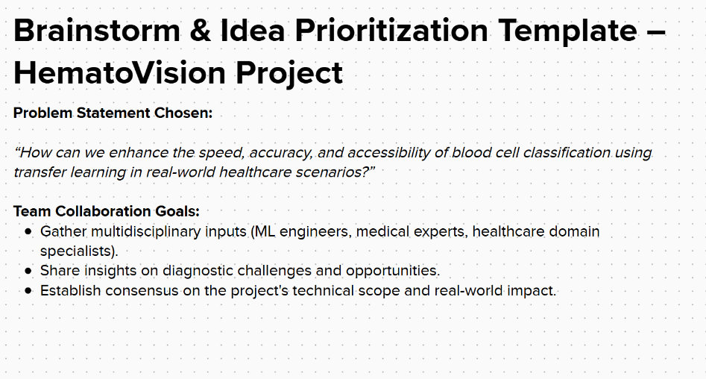

**Step-2: Brainstorm, Idea Listing and Grouping**

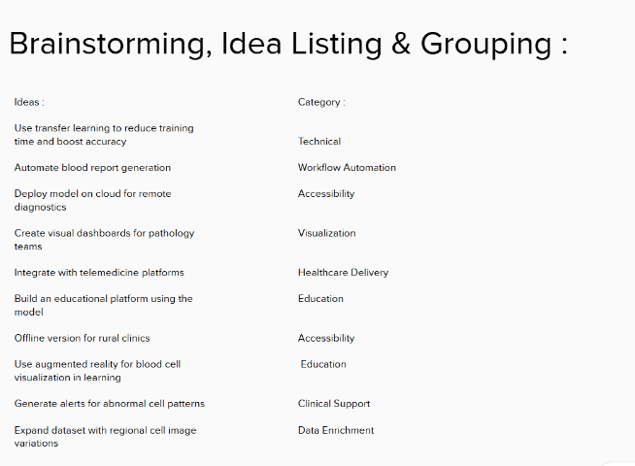

**Grouped Ideas by Theme:**

* **Clinical Automation:** Automated reports, real-time classification
* **Accessibility:** Cloud deployment, offline use in remote areas
* **Education:** Learning platform, AR for student interaction
* **Model Improvement:** Transfer learning, dataset enrichment

**Step-3: Idea Prioritization :**

